***Debugging Contest Solution***

**WebDownloader (7)**

* Conditions on the Main.java console interface should be (choice < 1 || choice > 3)
* WebDownloader line 149: loot = new FileOutputStream(new File(destination + f + ".pdf"));
* WebDownloader line 91: should be endIndex = i + 4

//Pattern matching check for file extension

else if (html.substring(i, i + fileExtension.length()).equals(fileExtension)) {

endIndex = i + 3;

}

* WebDownloader line 70: Incorrect calculation of files counted (unnecessary -1)  
   System.***out***.println("total files found: "+(files.size()- 1));
* WebDownloader line 154: incorrect execution time calculation
* Downloader.Main line 71 – 76: Switch statements reversed
* Downloader.Main line 97 – 102: Switch statements reversed
* **Bonus**: add error handling for string input

**Calculator (6)**

* Line 157 – 178: Operations are mixed up
* Line 128 – 138: Operations are mixed up
* Line 74: btnNum[i] = **new** JButton(1 + ""); should be btnNum[i] = **new** JButton(i + "");
* Line 151: need to set init = true;
* Line 171: result = result / Float.parseFloat(buffer); is missing
* Line 111: should be pnlOp.add(btnOp[i]);
* **Bonus**: Make the display display the most recently entered after an operation and update the display dynamically like a real calculator

**TextProcessor (5)**

* Line 29: should print out “Node Value: “ + n.c, not just n
* Trie Line 34: should print out n.leafValue for Hash code in print
* SearchEngine line 18: page counter should be initialized to 1 not 0
* SearchEngine line 39: need to increment page counter
* Trie line 31: should be < n.childValues.size() not <=
* Trie line 12: need to set pointer = root
* **Bonus**: Write a method to find and display all the pages a given word appears on
* **Bonus**: Write a method to calculate and display the total count of all the words in the text file.

**GeometryProcessor (7)**

* Main lines 37, 47, 57: Missing conditions to print grouped by shape (eg n % 3 == 0 for circles)
* Main lines 13, 15, 17: Cannot instantiate a shape
* Main line 11: Should be for(int n = 0; n < shapes[i].length; n++)
* Circle line 31: Area formula is wrong needs another * length
* Circle missing getColour() method
* Square missing getArea() method
* Triangle has wrong area formula should be (Math.*sqrt*(3) / 4) * length;
* **Bonus**: Code a 3dShape interface that includes a getVolume() method and code a Sphere, Cube, and Cylinder that implement it with the correct getVolume() implementation.
* **Bonus**: Produce a UML diagram of all the methods in the geometryProcessor package including the items created in the above bonus. This will only merit points after completing the first bonus.
* **Bonus**: Create a general method to sort all the Shapes in the 2D array by area. Write the code for this in the geometryProcessor.Main.java file.

General Schedule:

* Introduction to what we will be debugging and distribution of the file and how to import it into Eclipse
* Crash course in some useful debugging techniques
* Work on problems for remainder of time

Shape Main sample output:

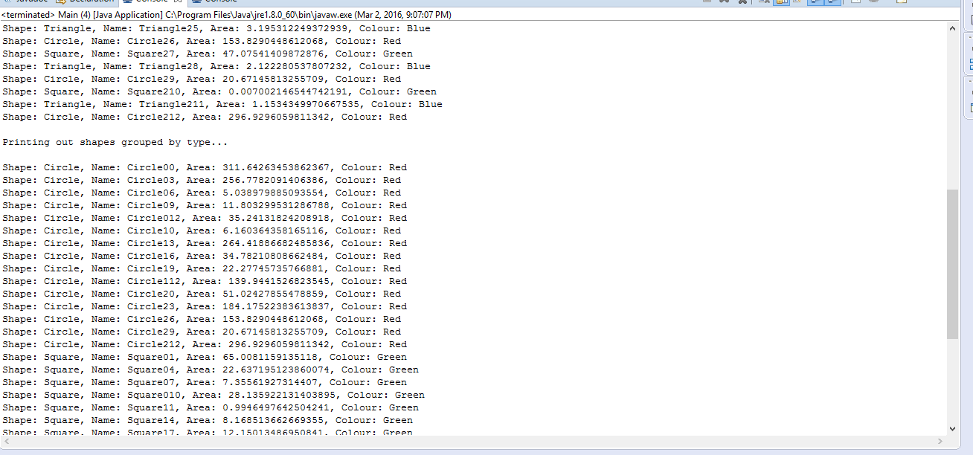

WebDownloader Main sample output:

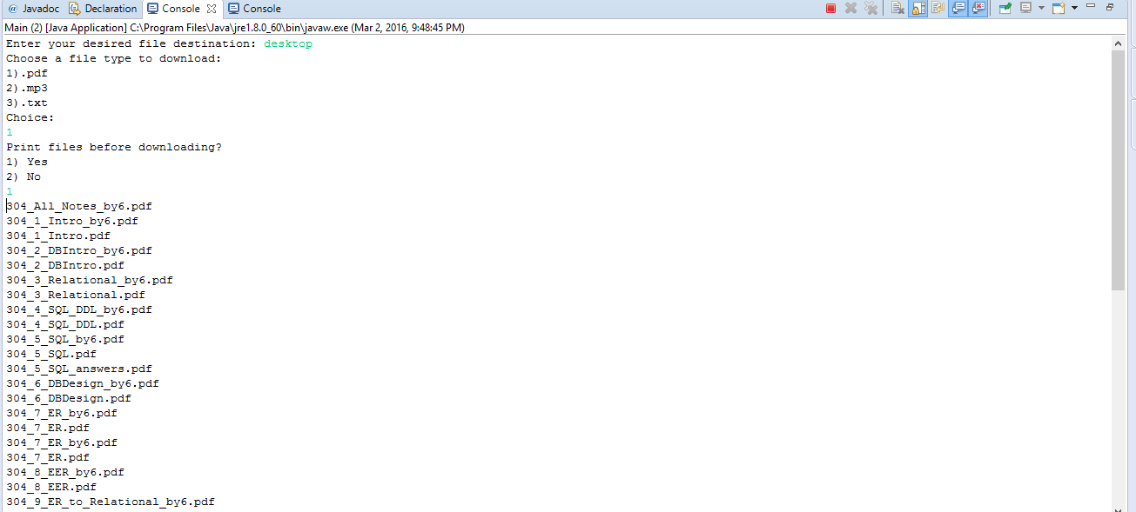

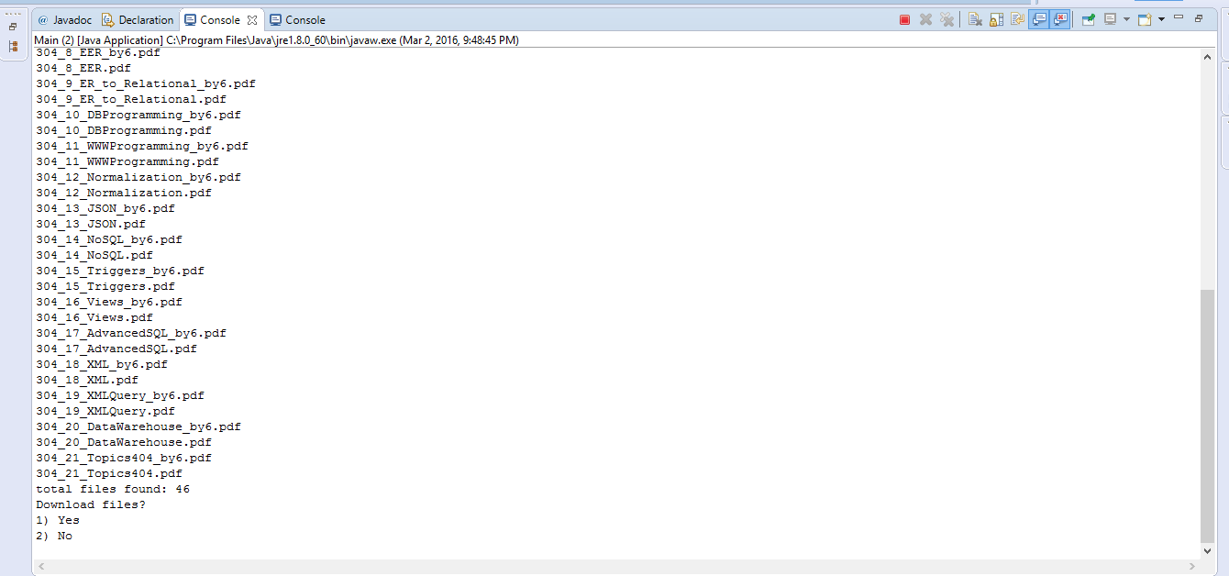

Calculator sample output:

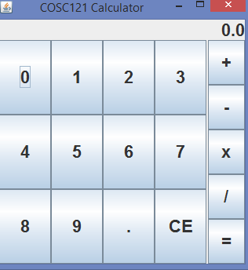

TextProcessor sample output:

